Contact: Ralf Trömer Marketing Tel.: +49 (0) 6405 / 89-353 Fax: +49 (0) 6405 / 89-374 E-Mail: r.troemer@roemheld.de Römheld GmbH Friedrichshütte Römheldstraße 1-5 35321 Laubach Germany Tel.: +49 (0) 6405 / 89-0 Fax: +49 (0) 6405 / 89-211 E-Mail: info@roemheld.de www.roemheld-gruppe.de | Römheld GmbH  Friedrichshütte  Römheldstraße 1-5  D-35321 Laubach  Germany  Tel.: +49 (0) 6405 / 89-0  Fax: +49 (0) 6405 / 89-211  E-Mail: info@roemheld.de  www.roemheld-gruppe.de
Pressinformation 1/2021

- ROEMHELD: Innovative clamping technology detects casting and contour defects of aluminium raw parts quickly and easily
- Reduce scrap drastically and monitor machining

With a new clamping technology concept aluminium blanks can be checked for casting defects and contour variations before machining at low cost and with little effort. Unsuitable parts can thus be rejected at an early stage.
The intelligent clamping technology also detects whether a workpiece is inserted incorrectly into a fixture. In addition, it continuously monitors the machining process, provides continuous information about the clamping position as well as the position and clamping force of the component and seamlessly documents the entire production process. ROEMHELD sees fields of application for this innovative clamping solution especially at suppliers of structural components for the automotive industry.
Pilot project of Wenzler and ROEMHELD reduces scrap significantly
Within the scope of a joint project, the clamping technology specialist ROEMHELD and August Wenzler Maschinenbau GmbH have developed the concept with the title "Innovative condition detection increases process reliability". Wenzler develops and manufactures 5-axis machining centres which are mainly used in the automotive industry for the machining of aluminium structural components.
Both companies were looking for a solution to the problem that undetected faulty cast aluminium blanks cause unnecessary costs. This is because the components are usually only inspected after machining. Especially in the automotive industry, lightweight aluminium parts, which are particularly thin-walled and filigree, often end up as rejects. This can be drastically reduced with the new clamping concept.

Clamping technology monitors the component on the fixture
In the innovation, various clamping elements take over the monitoring of the component clamped on the fixture. In the pilot project, for example, only two modified hydraulic standard swivel clamps equipped with sensors, one pressure sensor and two contact sensors are required for a cast aluminium rear axle frame. Through the correct arrangement of the elements and the transverse interrogation of the sensors, two electrified clamping points are sufficient to be able to make reliable statements:
- whether casting defects or contour variations affect the dimensional quality of a raw part beyond the
beyond the tolerance frame,
- whether the workpiece is correctly inserted and the clamping position is correct,
- whether the applied clamping force reaches the desired value,
- whether the contact force of the workpiece is within the specified limits, and
- whether the clamping pressure on the fixture corresponds to the specifications.
The ACTUAL data are then compared with the TARGET values on the display of the machine control. In case of deviations, the system refuses to start: if all tolerances are met, machining begins.
Use in series production before 2021
After the successful completion of the pilot project in 2020, the clamping concept is to be used in the machining of aluminium structural components at a German automotive supplier before the end of the year.

About ROEMHELD:
Whether aeroplanes, automobiles, machine tools or housings for smartphones: technologies and products from ROEMHELD have been used in the production of numerous industrial goods and goods for the end consumer for more than 60 years.
Efficient clamping technology solutions for workpieces as well as for tools in forming technology and plastics processing form the core of the continuously growing portfolio. It is supplemented by components and systems for assembly and handling technology, drive technology and automation, as well as locking systems for wind turbine rotors.
In addition to a constantly growing range of more than 30,000 catalogue articles ROEMHELD is specialised in the development and production of customer-specific solutions and is internationally considered as one of the market and quality leaders.
Innovation through tradition: ROEMHELD has its origin in the foundry Friedrichshütte, founded in 1707, which still belongs to the ROEMHELD Group and is one of the oldest active industrial companies in Germany.
The owner-managed group of companies employs about 560 employees at the three locations Laubach, Hilchenbach and Rankweil/Austria and is represented in more than 50 countries with service and sales companies. With customers especially from the mechanical engineering, automotive, aviation and agricultural industries ROEMHELD achieves an annual turnover of more than 110 million Euros.

Video “Innovative condition detection increases process reliability”: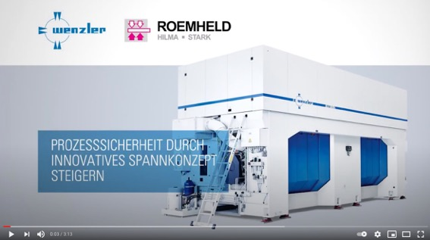
https://www.youtube.com/watch?v=6HBBS1nFlX8
Photos:
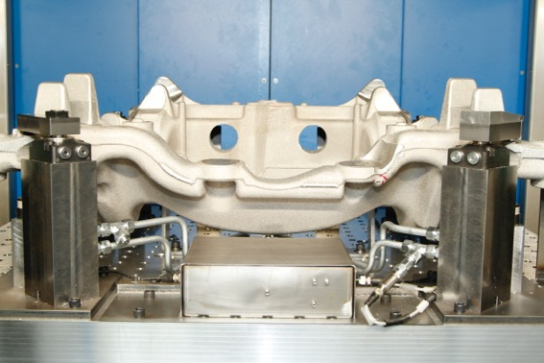
Photo 1:
With the new concept “Innovative condition detection increases process reliability”, castings can be inspected before machining. Also, their quality can be continuously monitored and seamlessly documented during the entire production process. Mounting of a test fixture on a machine in Wenzler’s TechCenter. (Photo: Wenzler).
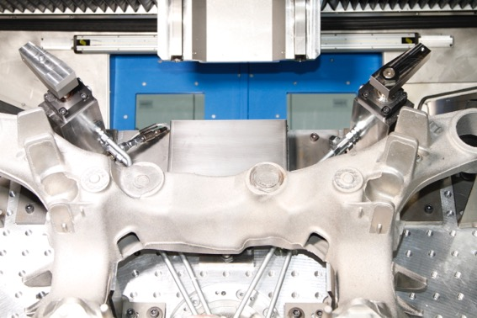
Photo 2:
Two modified hydraulic standard swing clamps equipped with sensors and a pressure sensor from ROEMHELD are used on the fixture to collect the required data. Mounting of a test fixture on a machine in Wenzler’s TechCenter. (Photo: Wenzler).

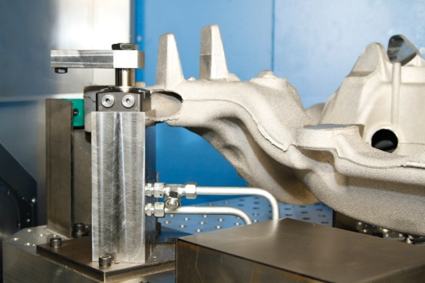
Photo 3:
One modified hydraulic standard swing clamp directly queries the clamping and support forces at clamping point 1. (Photo: Wenzler).
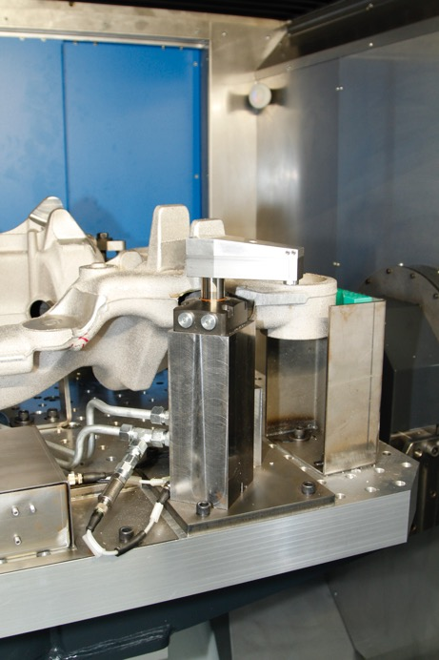
Photo 4:
A swing clamp with an additional integrated stroke measurement is used at clamping point 2 to determine the clamping arm’s position. Furthermore, the contact force is determined directly via a sensor. An additional pressure sensor (bottom left) indirectly measures the clamping force (Photo: Wenzler).
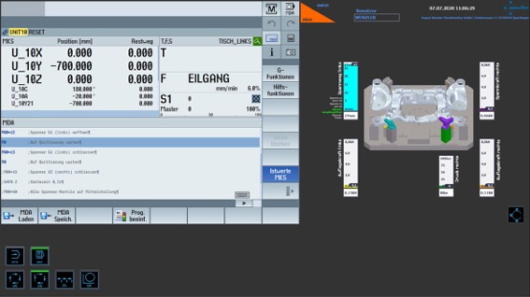
Photo 5:
The display shows the system status “Loading/unloading workpiece released”, all elements are in a defined position (Photo: Wenzler).
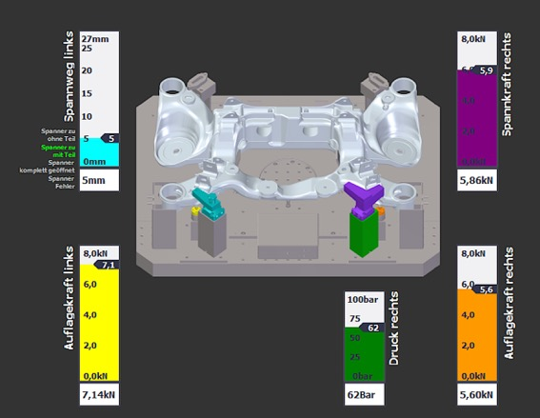
Photo 6:
The display shows that all ACTUAL data match the TARGET values. Machining can start (Photo: Wenzler).

Photo 7:
Sebastian Knaus, Technical Manager August Wenzler Maschinenbau GmbH (Photo: Wenzler).

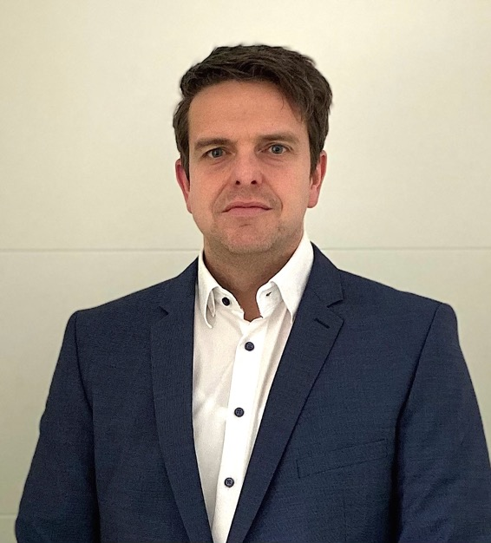
Photo 8:
Benjamin Nagel, Key Account Manager Römheld GmbH Friedrichshütte (Photo: ROEMHELD).
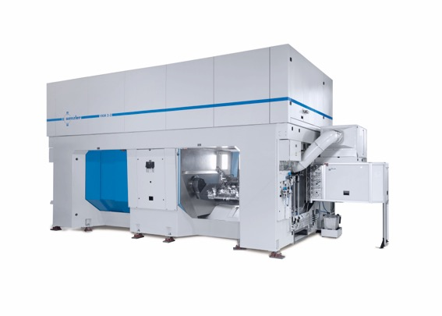
Photo 9:
The majority of Wenzler’s customers come from the automotive industry; they primarily machine chassis and suspension components made of aluminum on the 5-axis machining centers. (Photo: Wenzler).

